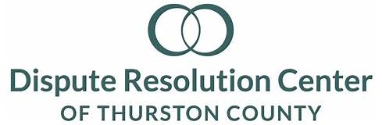
Executive Director’s Board Report
April, 2022

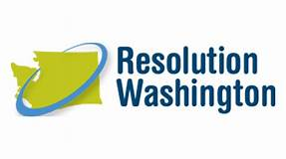
Celebrations
While the Washington State Legislature passed a supplemental budget in which Resolution Washington was allocated an additional $3M for ERPP starting July 1, the request for gap funding from April to June was not fulfilled. For our center, that equates to approximately $55,000 dollars of funding needed that was unavailable. However, Resolution Washington successfully engaged with the Administrative Office of the Courts, who has offered to identify these funds from within their own budget so that we can keep operating the ERPP program at current levels, prior to funding boosts that will come July 1.

Latest News & Updates
The Suite A building work is done with wall removal, beam support, rewiring, carpet patching and painting. So, we are beginning to stage for our open house. Now, Suite B will be getting an upgrade in LED overhead lighting as well as window coverings in all offices, which will reduce our ongoing energy bills.

Recent hire Mattie Leighton has been a real asset to our Eviction Resolution Pilot Program case support team, in a time of extremely high case volume. Caseload has increased month over month by 30%, with April easily having our highest case volume ever. Team members Chad, Isaid, Yul and Mattie, along with their supervisor Alice are working extremely hard to manage expectations while being responsive and thorough in case management. As we prepare for Isaid’s departure for law school in the summer, we are actively recruiting another person to join the team in May so as to support current caseload while having an overlapping learning experience while Isaid is still with us. We are committed to centering the needs of our Spanish-speaking community, so our hope is to be able to hire another bilingual, bicultural member of the team.

A Request
Please remember to invite community leaders, friends and others you know that may have interest in our work to our open house on Sunday, April 24! Joe and Robyn have crafted a great event, in partnership with the Community Engagement Committee members. Attendees can take a self-guided tour of our expanded space, while enjoying tasty snacks and chocolates. Copies of our recently published 30-year anniversary booklet will be provided to everyone in attendance.

