Executive Director’s Board Report
June 13, 2022

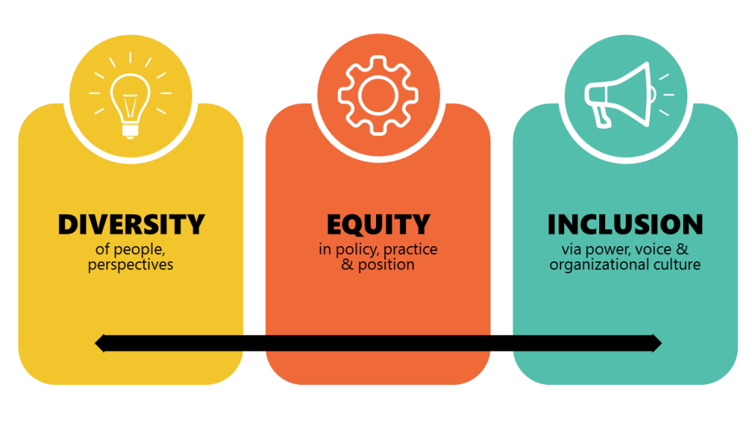
Celebrations
ResWA recently held our annual Directors’ retreat that spans three days. As part of that meeting where we make strategic decisions for the year ahead, including funding allocations for all centers in the state, we spent a portion of our first day with Pamela Oakes, formerly of the Gates Foundation. Pamela’s presence was focused on supporting and continuing our efforts to address diversity, equity and inclusion in our centers. The celebration herein is that I felt a great deal of affirmation that our center is taking the right actions moving forward on our commitments with: a steady presence of staff conversations, led by our leadership team; training up two team members in the Intercultural Foundations assessment model; and adding in more transparency for new hires on expectations of personnel regarding personal awareness, team responsibilities and contribution to co-creation of a thriving, inclusive, truly community-based organization.
Programs Snapshot
May was a record-breaker month for ERPP with 570 notices, and 661 inquiries overall (some folks reach out without a notice being filed)!
Fundraising News
We received three grant awards in the last month - two of which are not regular funders of the DRC - the Forest Foundation, for capacity building and the Department of Commerce, for housing stability work. The third was an unsolicited gift in memory of Hannah Steinweg McDonald. With these funds, we are able to proceed with another tech investment, our meeting owl, and build more stability into alternative, preventative housing stability work!
Staffing Updates
Exciting movement is underfoot in staffing our housing program – we are hiring Luis Manzo for the role of Housing Manager. Luis has a background in youth support services and has been a long-time team manager. Mattie Leighton has been promoted into the role of Resolution Specialist, after wowing us all in her short term as Case Support Specialist. Leah Rietema is joining our team as Case Support Specialist. Leah is a highly capable, new graduate of OSU who speaks in the language of needs and values – she's a great fit for our team!
Stewardship
Expanded community partnerships are underway with three organizations that we have long worked with. Two of our financial partners, Twin Star and WSECU have both responded to our request to create a warm hand-off referral process for clients needing financial guidance and support prior to entering into agreements that affect their future. This has been an occasional need within family cases over the years and has surfaced much more frequently within our housing program work. In addition, CIELO has recently hired a new Executive Director that shares a similar vision of collaboration on shared interests in community, and we are delighted to proceed on several initiatives that have been in their infancy over the last few years, including: having a more regular stream of bilingual/bicultural interns; making space for promising youth leaders in the Professional Mediation Training; and, contributing to events and programs that build trust and understanding about how our services can support CIELO clients and vice versa.

