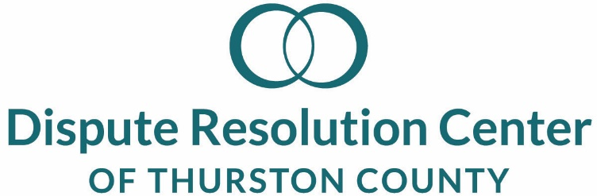

Board of Directors
Youth Representative

The Dispute Resolution Center empowers people to resolve their disputes by providing direct conflict resolution services and training community members in those skills. We envision a South Sound community that has and uses healthy and respectful conflict resolution skills. We value personal empowerment, integrity, respect, collaboration, civility, and trust.

The DRC story in Thurston County began in 1990 with the simple notion that people can settle their own disputes and learn effective communications with the help of others who have learned practical, teachable and highly effective skills as neutral facilitators. The Dispute Resolution Center of Thurston County is one of 22 DRCs operating independently and collaboratively to serve Washington State.

Mission, Vision and Values
The Dispute Resolution Center empowers people to resolve their disputes by providing conflict resolution services and training community members in those skills.

We envision a South Sound community that has and uses healthy and respectful conflict resolution skills.

We value personal empowerment, integrity, respect, collaboration, civility, and trust.

About the Board of Directors:
The DRC Board of Directors is comprised of up to 15 community volunteers who are strong advocates for conflict resolution, civility, and promoting respect and peace in the communities the DRC serves. The DRC Board believes that youth are a much-needed resource in our community and that we need the perspective of youth as part of the Board. We value inclusiveness, consensus, participation, responsiveness, transparency, accountability and efficiency,.

Youth Representative Role & Responsibilities:
  - Be a full Board Member responsible for providing general, personal, and youth perspectives to assist the Board in the consideration of DRC issues and decisions.
  - Serve a one-year term October through September with the Board of Directors. This appointment may be renewed one time for a total of two years.
  - Attend monthly Board Meetings - usually held on the third Thursday of each month – 5:30 to 7:00 p.m. They will attend the Annual “Toast” fundraiser in April, the annual Board Retreat in November, and a minimum of one other DRC community event of their choice. They are encouraged to also participate on one of the committees.
  - Participate in orientation to become familiar with the bylaws and business of the DRC.
  - All board members are required to come prepared to meetings by reviewing minutes of Board meetings, financial statements, and other materials before meetings.
  - Represent own opinions.
  - Help recruit other youth to apply to become a future Youth Board Representative.
  - Sign and abide by declarations of confidentiality and conflict of interest.
  - Observe and/or complete trainings offered by the DRC.
  - Serve as a goodwill ambassador for the organization and its programs.
  - Take seriously the legal, fiscal, and ethical responsibilities of the Board.
  - Engage with assigned mentor on Board goals, mechanics, planning, and other topics.

Qualifications:
  - Be between 16 and 24 years of age as of the beginning of their first term as Board Member.
  - Have a demonstrated interest in community peace and conflict resolution.

Time Commitments:
  - Board meetings: 1.5 hours per month
  - Committee meetings 1½ hours per month
  - Other projects such as fundraising and/or event support, etc: average 1+ hours per month

Opportunity for Applicant:
As for all Board members, this is a volunteer position; however, the following is offered:
  - Reduced fee for most trainings
  - Letter of recommendation upon successful conclusion of term
  - Resume enhancer
  - Mentorship by experienced professional

DRC Commitment to Members of the Board of Directors:
  - Provide board meeting agendas and other meeting materials in advance, including a monthly financial status report and a Board portal for easy access to information about the DRC and Board calendar and work.
  - Access to the Executive Director, committee chairs, and/or chair of the Board to discuss the programs, policies, goals and objectives of the organization.
  - Thorough and timely responses to questions regarding legal, fiduciary or other responsibilities to the organization.

To Apply:
Complete and submit the application form (below) to info@mediatethurston.org by September 15th. It is optional to submit a resume. Selected applicants will be contacted for interview and/or additional information. Youth members under the age of 18 will also be required to have a signed authorization to participate by its parent or guardian. Questions? Call the Executive Director at 360.956.1155.

Board of Directors
Youth Representative

Name:_________________________________________Phone: ______________________________

Email: _________________________________________

Emergency Contact

Name:_____________________Relationship:______________________ Phone:_________________

Please feel free to use additional paper or space if needed for the following questions.

I am interested in serving as a Youth Representative Board Member for the Thurston and Mason County Dispute Resolution Center because:

List learning, paid or volunteer work, or other experiences that demonstrate your interest in civic harmony, dispute resolution, and/or world peace:

Experience:

How it demonstrates my interest:

The following persons have agreed to serve as references for me:

Name: _________________________________Relationship:____________________________

Phone:_________________________________Email:__________________________________

Name: _________________________________Relationship:____________________________

Phone:_________________________________Email:__________________________________

