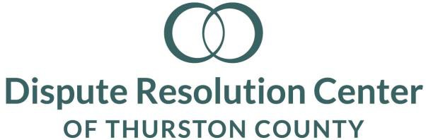
Youth Representative Candidate Interview Questions
Candidate:_____________________________________
Date:__________________________________________
Committee Member:_____________________________
The Dispute Resolution Center empowers people to resolve their disputes by providing conflict resolution services and training community members in those skills.
Thank you for your interest and completing the application process. The DRC Board believes that youth are a much-needed resource in our community and seeks the perspective of youth as part of the Board. We value inclusiveness, consensus, participation, responsiveness, transparency, accountability and efficiency.
- How did you learn about the new position of Youth Representative for the DRC Board?

- What do you already know about the DRC?

- Please share why are you interested in committing your time and energy to this board.

- Board members each bring unique experience, perspectives, strategic thinking, and connections. Would you please tell us about yours?

- What experiences might you have had with conflict resolution, peacemaking, dealing with confidentiality?

- What characteristics would an effective Youth Board Member exhibit?

- What leadership roles, such as service organizations, committees, selected or elected positions have you experienced to date?

- How do you believe your peers would support you serving as a non-profit Youth Board Member?

- Attending meetings, retreats, possibly observing trainings and participating in fundraising activities are significant obligations of board service.

- What steps would you take if you had a concern or inquiry that was not expressed at a meeting or in-between meetings?

- Do you have any questions or concerns about our expectations of you as a Youth Board Member?

- If selected, how would you want to be remembered?

- Any additional questions for us?

